"International Summer School ATU - 2019" - Almaty Technological University offers summer school program for students and masters in the direction of "Biotechnology" to develop academic mobility between specialized universities
Purpose of program – to acquaint students with the methods of biotechnology used in food production and plant breeding.
School objectives: theoretical and practical introduction to modern methods of biotechnology used in food production and plant breeding.
Study results:
- know the possibilities of using biotechnological approaches to food production , the decision of the selection problems;
- to know the basic methods of plant cell selection;
- know the scheme and the production technology of biotechnology products;
- know microorganisms culture conditions, plant cells to obtain the desired product ;
- to know the methods of analysis and control of food safety, quality of raw materials, intermediate products and other products.
ACTIVITY
The event is held for 5 days on the basis of the ATU technopark, equipped with new equipment.
The summer school includes lectures, seminars and thematic workshops in the following areas: food production, in particular on the biotechnology of dairy products, biotechnology of functional foods, food and biological additives; plant biotechnology, obtaining plant cell culture. The program includes excursions at leading enterprises of the food industry, visits to research institutes.
As part of the summer school program, cultural events are held: celebrations, concerts, photo shoots, open presentations of workshops, an introductory tour of Almaty
Members
Lecturers of the International Summer School ATU -2019 are famous researchers, scientists, masters of the leading enterprises of the Republic of Kazakhstan.
Below are some of them:
Shayakhmetova I.Sh. - candidate of Biological Sciences, Department of PB, Faculty of Food Production, ATU, The best teacher of the university -2018
Lesova ZhT. - candidate of Biological Sciences, prof. ATU, Department of PB, Faculty of Food Production, ATU, The best teacher of the university, 2010, is engaged in scientific research on the following topics: Getting virus-free potatoes, accelerated reproduction of healthy potato planting material, Reproduction of vegetables and berries by the method of hydroponics, Accelerated reproduction of medicinal plants (prevention of diabetes , immunostimulating, hepatoprotective), Microclonal reproduction of flower and shrub cultures
Velyamov M.T. - Doctor of Biological Sciences, Professor, Academician of the AASN RK and the Russian Academy of Natural Sciences
Seidakhmetova Z.ZH. - Doctor of Biological Sciences, Associate Professor, Department of PB, Faculty of Food Production, ATU
The geography of the participants of the International Summer School ATU -2019 - students of universities in Almaty, as well as regional universities of the Republic of Kazakhstan and the near abroad.

SUMMER SCHOOL PROGRAM
Time | Occupation name | Full name of the teacher | Location of the lesson
1 day

9.00-10.00 | Registration of participants, 1st floor, lobby 2A
10.00-11.00 | Acquaintance with the specialties of the Faculty - Dean of the Faculty of Food Production Ph.D., Associate Professor Zhaksylykova G.N.
11.00 –11.30 | Lecture: Presentation of the specialty "Biotechnology" ATU - Head of the Department "Food Biotechnology" | Candidate of Biological Sciences,  ass.prof Aralbayeva A.N. | Building 2A, 8th floor, 801
11.30 –13.00 | Lecture: The use of biotechnological methods in the food industry | Candidate of Biological Sciences  Acting docent, Ph.D. Zhaparkulova N.I. | Building 2A, 8th floor, 801
13.00- 14.00 | Lunch break
14.00 -15.00 | Exercise: Using Food Additives in Food Technology | Acting Associate Professor, Candidate of Biological Sciences  Shayakhmetova I.Sh. | Building 2A, 8th floor, 801
15.00 -17.00 | Master Class: Functional Food Biotechnology | Doctor of Biological Sciences, Professor, Academician of the AASN RK, Velyamov M.T. | Building 2A, 8th floor, 801
2 day

10.00- 11.00 | Lecture: Cell selection of crops for resistance to the stressful effects of the external environment | Candidate of Biological Sciences, prof. ATU Lesova ZH.T | Building 2A, 8th floor, 801
11.00-12.00 | Lecture: Improvement of agricultural crops from phytopathogens using biotechnology methods | Candidate of Biological Sciences, prof. ATU Lesova ZH.T | Building 2A, 8th floor, 801
12.00-13.00 | Master class: "Obtaining cell culture of plants (potatoes, wheat, microcloning of test | Candidate of Biological Sciences, prof. ATU Lesova ZH.T | Building 2A, 8th floor, 806
13.00- 14.00 | Lunch break
14.00-17.00 | Excursion to the enterprise: KazNIIZhiKP, laboratories of KazNIIZhiKP, JSC Kazakh Academy of Nutrition, Almaty | Acting docent, candidate of Agricultural Sciences  Katasheva A.Ch.
3 day

10.00- 11.00 | Lecture: Biotechnological equipment and its use in food enterprises | Candidate of Technical Sciences, associate professor Shambulov GD | Building 2A, 8th floor, 801
11.00-13.00 | Practical lesson: "The use of lactic acid bacteria in the production of functional dairy products" | Dr. Phd, Nabiyeva Zh. | Building 2A, 8th floor, 801
13.00-14.30 | Lunch break
14.00-17.00 | Round table; Biotechnology of milk and dairy products. Requirements for storage conditions of dairy products. Consumer Information | Doctor of Biological sciences, Acting Professor Seidakhmetova Z.Zh. | Building 2A, 8th floor, 801
4 day |  |  |  |  |  | Корпус 2А, 8 этаж, 801
10.00- 11.00 | Lecture: Opportunities and prospects of genetic engineering in improving and improving the quality of crops | Acting Professor, candidate of Biological sciences,  Amirova A.K. | Building 2A, 8th floor, 801
11.00- 13.00 | Master Class: Modern Methods for Researching the Gene Pool of Agricultural Plants | Acting Professor, candidate  Amirova A.K. | Building 2A, 8th floor, 806
13.00-14.00 | Lunch break
14.00-17.00 | Presentation of presentations of participants
5 day

10.00-13.00 | Lecture: Prospects and opportunities of "green technologies" - prof. ATU | Acting Associate Professor, Candidate of Biological Sciences  Shayakhmetova I.Sh. | Building 2A, 8th floor, 801
10.00-12.00 | Visiting research institute and university technopark | Candidate biological sciences, ass/professor Aralbayeva A.N. | Building 2A, 8th floor, 801
12.00- 13.00 | Lunch break
13.00-14.00 | Summer school closing. Presentation of certificates | Dean FPP, Ph.D., associate professor Zhaksylykova G.N.  Head of the Department of PB Ph.D., Ass. Aralbayeva A.N. | Building 2A, 8th floor, 801
14.00-17.00 | Almaty city tour

The duration of the program is 30 hours.
According to the results of the international summer school, participants are given a certificate.
Participation in the summer school is 15,000 (fifteen thousand) tenge, including payment for living in a dormitory. The cost of travel and meals are paid by the participants themselves.
The period of passage of the summer school from June 3 to June 07, 2019

MATERIAL BASE OF THE DEPARTMENT
"FOOD BIOTECHNOLOGY"

Laboratories of microbiology, biochemistry and biotechnology:

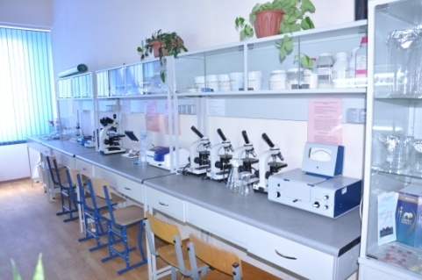 | 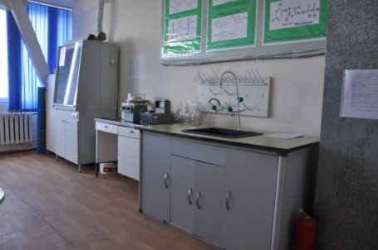 | 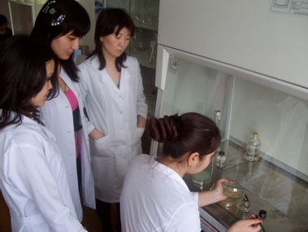
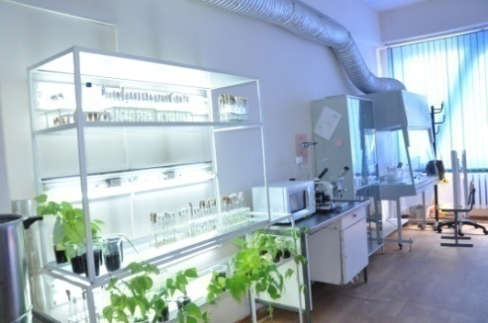 | 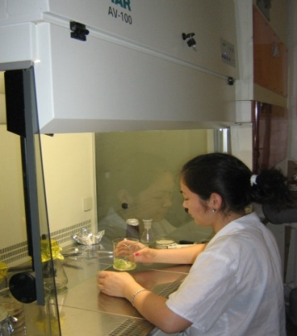 | 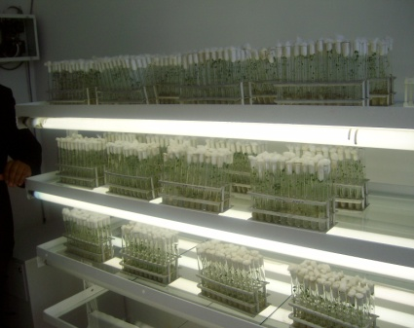
 | 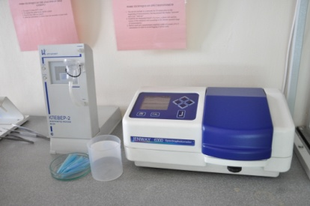 | 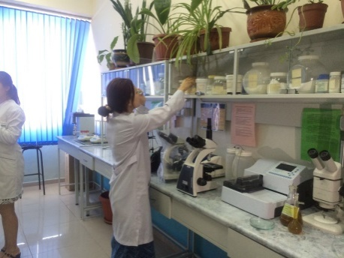
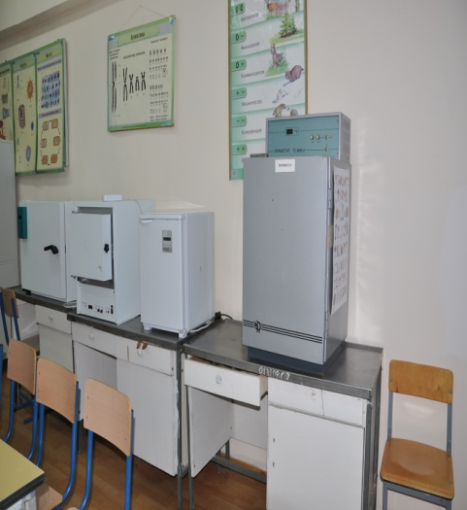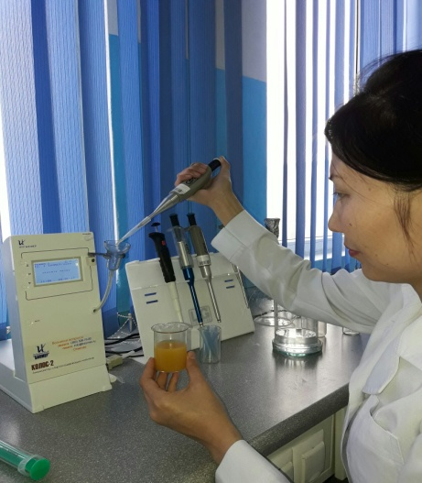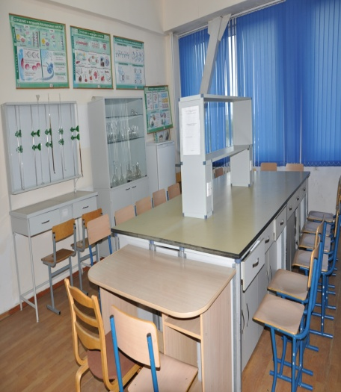
Laboratories Research Institute of Food Safety and Expertise ATU

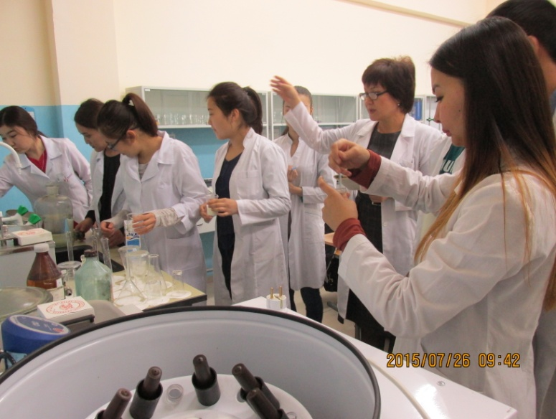 | 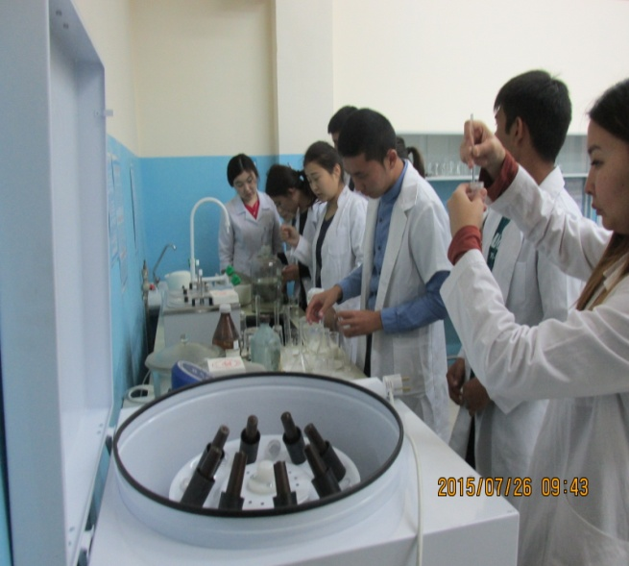
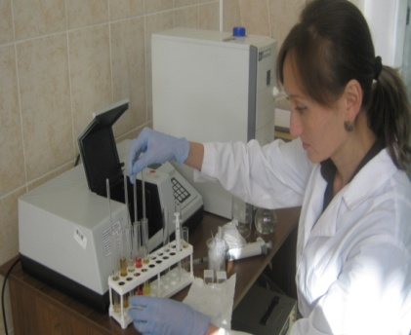 | 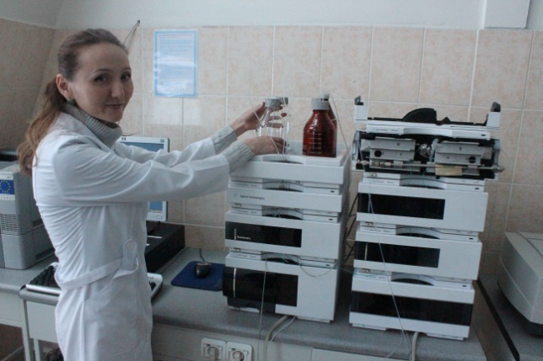
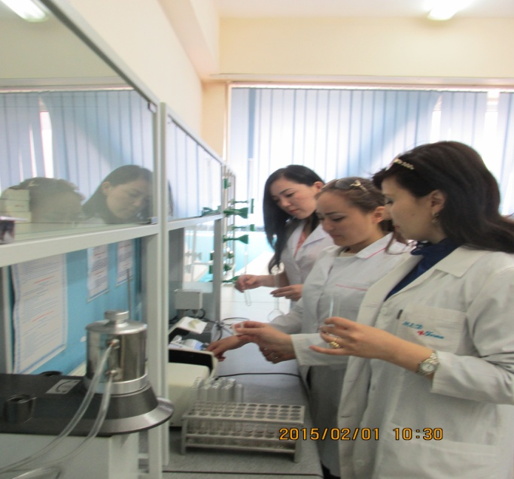 | 